Faculty of Engineering, Science & Technology
IQRA UNIVERSITY



Programming Fundamentals
Project Report
[Fall-2024]

Names: Kashif Raza & Ameen Dahani
Roll no: 17221, 17115
Semester: 2nd
Batch:

Instructor Name: Ghazala Shafi Sheikh

Acknowledgment

I would like to extend my gratitude to Miss Ghazala for invaluable guidance and dedication in teaching us the programming fundamentals using C++. Your engaging teaching style and ability to simplify complex concepts have been instrumental in building our foundation in programming.

Thank you, Miss Ghazala, for your patience, knowledge, and commitment to our learning journey. Your efforts have truly made a lasting impact on our understanding and confidence in programming.

Thank you
Miss Ghazala Shafi Sheikh

Chapter 1 Index Pages
Objectives 4
Chapter 2
Introduction 5
Chapter 3
Description 6
Chapter 5
Screenshots
7
Chapter 6
Conclusion 8

1.Objectives:
- To develop a simple and interactive Inventory Management System using C++.
- To demonstrate the use of structs, vectors, and functions in organizing and managing inventory data.
- To provide a menu-driven interface for users to perform common inventory operations like adding, displaying, searching, updating, and deleting items.
- To enhance the understanding of iterative control structures (do-while loop) and conditional decision-making (switch statement).

2.Introduction:

The Inventory Management System is a C++ program designed to simulate a basic inventory management application. It allows users to keep track of items, including their names, quantities, and prices. By leveraging the vector container, the program dynamically manages the inventory without a fixed size. The system is modularized using functions for better readability, maintainability, and scalability. This program is an excellent demonstration of object-oriented concepts like encapsulation and practical usage of data structures in real-world applications.

3.Description:
The program is divided into the following components:
- Data Structure:
  - A struct Item is defined to store details of each inventory item, including:
    - name: A string representing the name of the item.
    - quantity: An int for the count of the item in stock.
    - price: A double to store the cost per item.
- Key Functionalities:
  - Adding an Item: The addItem() function allows users to input new item details and add them to the inventory.
  - Displaying Inventory: The displayInventory() function displays all the items currently in stock with their details.
  - Searching for an Item: The searchItem() function searches the inventory for an item by name and displays its details if found.
  - Updating Quantity: The updateQuantity() function lets users modify the quantity of an existing item.
  - Deleting an Item: The deleteItem() function removes an item from the inventory by its name.
- User Interface:
  - A menu-driven system in the main() function provides options for interacting with the inventory system.
  - A do-while loop ensures the menu keeps running until the user chooses to exit.
- Dynamic Storage:
  - The vector<Item> is used for storing the inventory items, offering flexibility in managing a dynamic number of entries without the need for manual memory allocation.
- Control Flow:
  - The switch statement handles user input and redirects to appropriate functions based on the selected menu option.

4.Screen Shots:
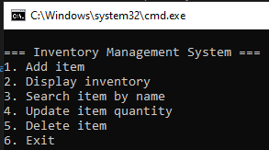
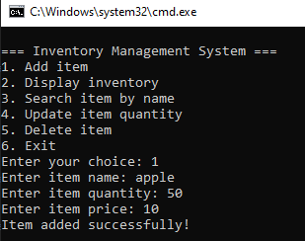
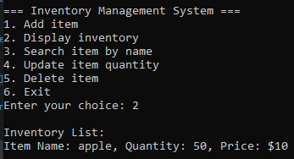
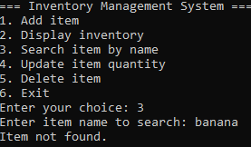
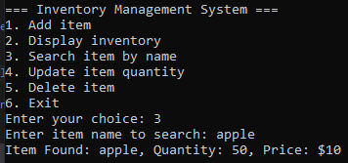
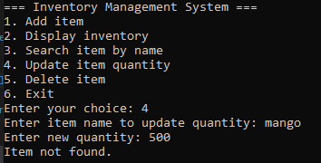
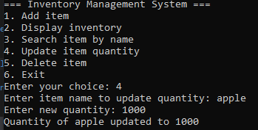
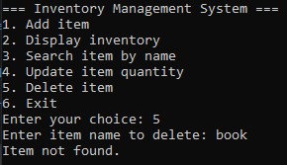
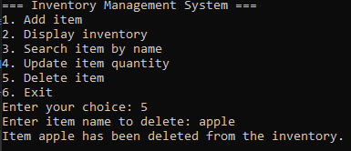

5.Conclusion:
The C++ program provides an efficient and straightforward solution for managing inventory. By incorporating essential programming concepts such as data structures, loops, and modularity, it ensures clarity, flexibility, and ease of use.

